QUANTUM WOLF

DATA INTELLIGENCE AND RESEARCH LAB

**DATE:10-03-2025**

**NAME:ABDUL ZUHAIL M**

**Smart Dust Networks: Packet Loss Minimization in Submillimeter Sensor Communication**

**1. Problem Statement**

Smart Dust Networks utilize submillimeter-scale wireless sensors for environmental data collection. However, dense deployments result in high signal interference and packet loss of up to 40%, limiting data reliability. This problem significantly affects applications such as precision agriculture and environmental monitoring, where real-time data accuracy is crucial.

**2. Introduction**

The primary challenge in Smart Dust Networks is managing efficient communication between motes while mitigating signal loss. Conventional routing methods fail to adapt dynamically to interference variations, leading to frequent data retransmissions and inefficient power consumption. This project focuses on minimizing packet loss and improving routing efficiency using AI-driven techniques within Orange, a data visualization and analysis tool. The dataset used in this project is generated by ChatGPT to simulate real-world sensor network conditions.

**3. Solution Approach**

This project implements a data-driven workflow in Orange to optimize signal routing. The methodology involves:

* **Data Preprocessing & Feature Engineering** – Ensuring high-quality input for modeling.
* **Feature Selection & Dimensionality Reduction** – Identifying key attributes affecting routing.
* **Clustering for Network Analysis** – Understanding interference zones.
* **Machine Learning-Based Routing Decisions** – Implementing a decision tree model for optimized routing.
* **Python-Based Adaptive Routing** – Fine-tuning routing paths dynamically using interference predictions.

**4. Smart Dust Routing Optimization - Orange Workflow Implementation**

**Step 1: Data Import**

**Objective:** Load the dataset containing sensor attributes (e.g., signal strength, packet loss, humidity, temperature, and interference levels). The dataset used in this project is generated by ChatGPT.

**Widgets Used:**

* File (Loads the dataset into Orange.)
* Data Table (Displays raw data for verification.)

**Output:**

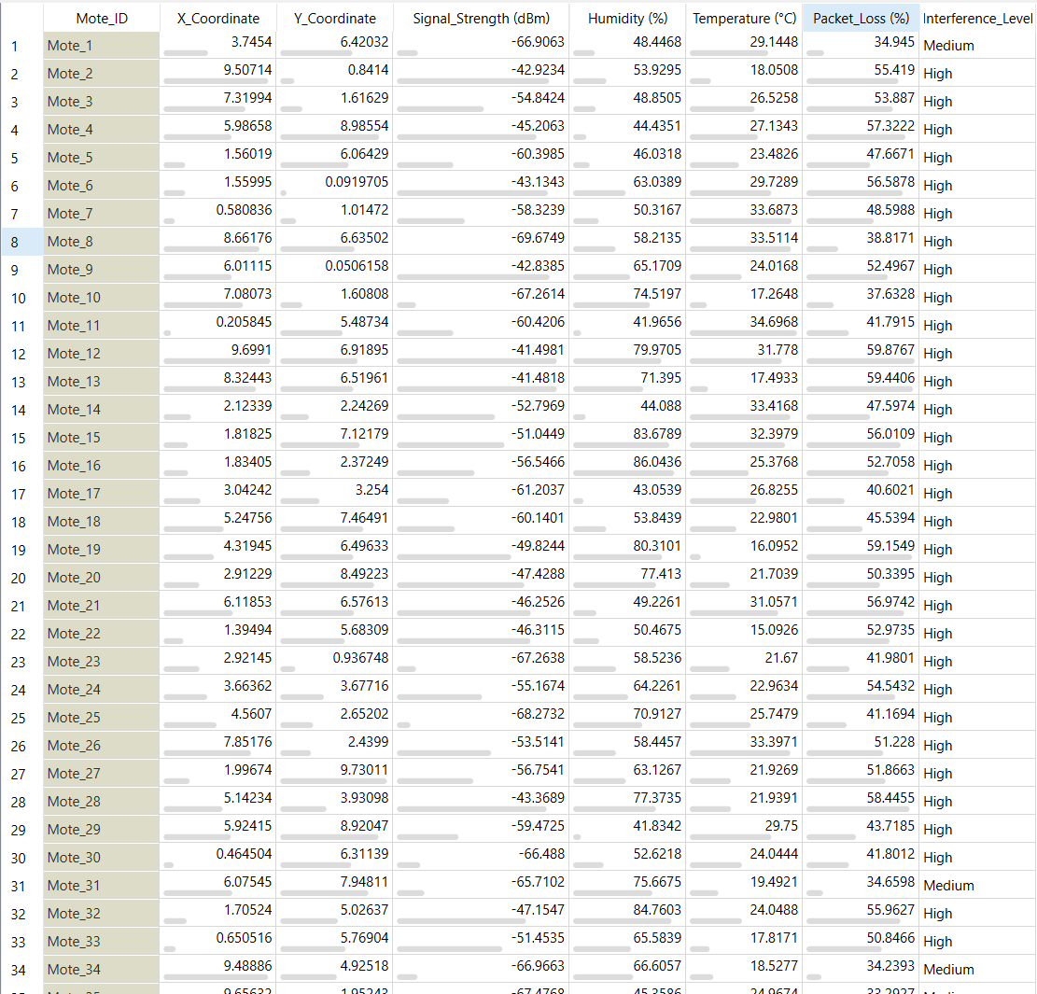

**Step 2: Data Preprocessing**

**2.1. Select Columns**

* **Objective:** Retain only relevant features required for routing decisions.
* **Widgets Used:** Select Columns (Filters necessary features.)

**2.2. Handle Missing Values**

* **Objective:** Ensure no gaps exist in the dataset.
* **Widgets Used:** Impute (Fills missing numerical values with mean, categorical values with mode.)

**2.3. Modify Domain**

* **Objective:** Ensure proper data types and conversions where necessary.
* **Widgets Used:** Edit Domain (Modifies feature types.)

**Step 3: Feature Ranking & Reduction**

**3.1. Rank Features**

* **Objective:** Identify the most significant features influencing routing efficiency.
* **Widgets Used:** Rank (Ranks features based on predictive power.)

**Feature Importance Ranking:**

1. Signal Strength (dBm)
2. Packet Loss (%)
3. Y Coordinate
4. Humidity (%)
5. Temperature (°C)
6. X Coordinate

**3.2. Apply PCA for Dimensionality Reduction**

* **Objective:** Reduce redundant data while preserving critical variance.
* **Widgets Used:** PCA (Performs dimensionality reduction.)

**PCA Analysis:**

* The **variance explained** by the principal components is visualized.
* **Cumulative variance** shows how much of the data variance is retained as more principal components are included.

**Output:**

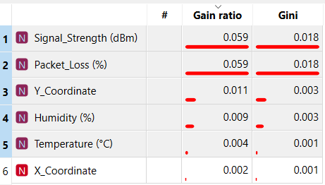 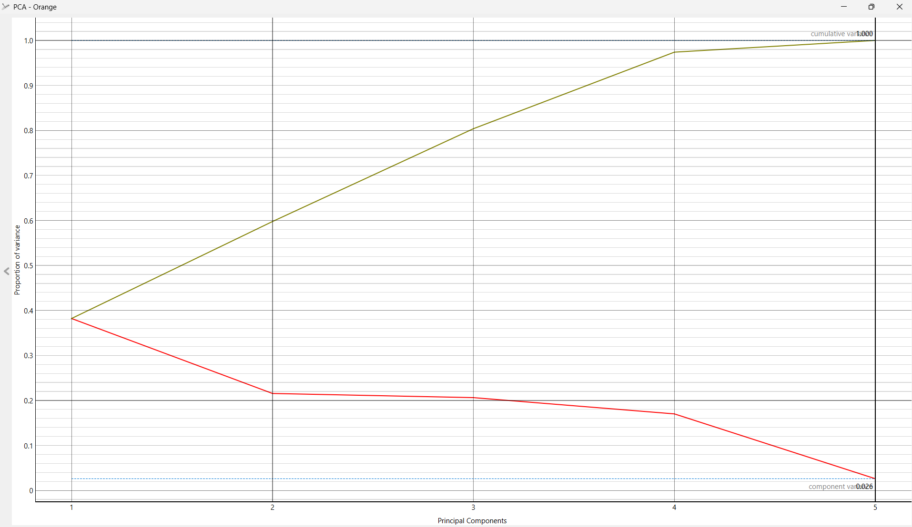

**Step 4: Clustering & Routing Analysis**

**4.1. Apply k-Means Clustering**

* **Objective:** Categorize nodes based on network behavior and interference levels.
* **Widgets Used:** k-Means (Performs clustering based on similarity.)

**4.2. Visualize Clusters**

* **Objective:** Gain insights into cluster distribution.
* **Widgets Used:** Scatter Plot (Plots clustering results.)
* **Box Plot (Analyzes variability in signal parameters.)**

**Output:**

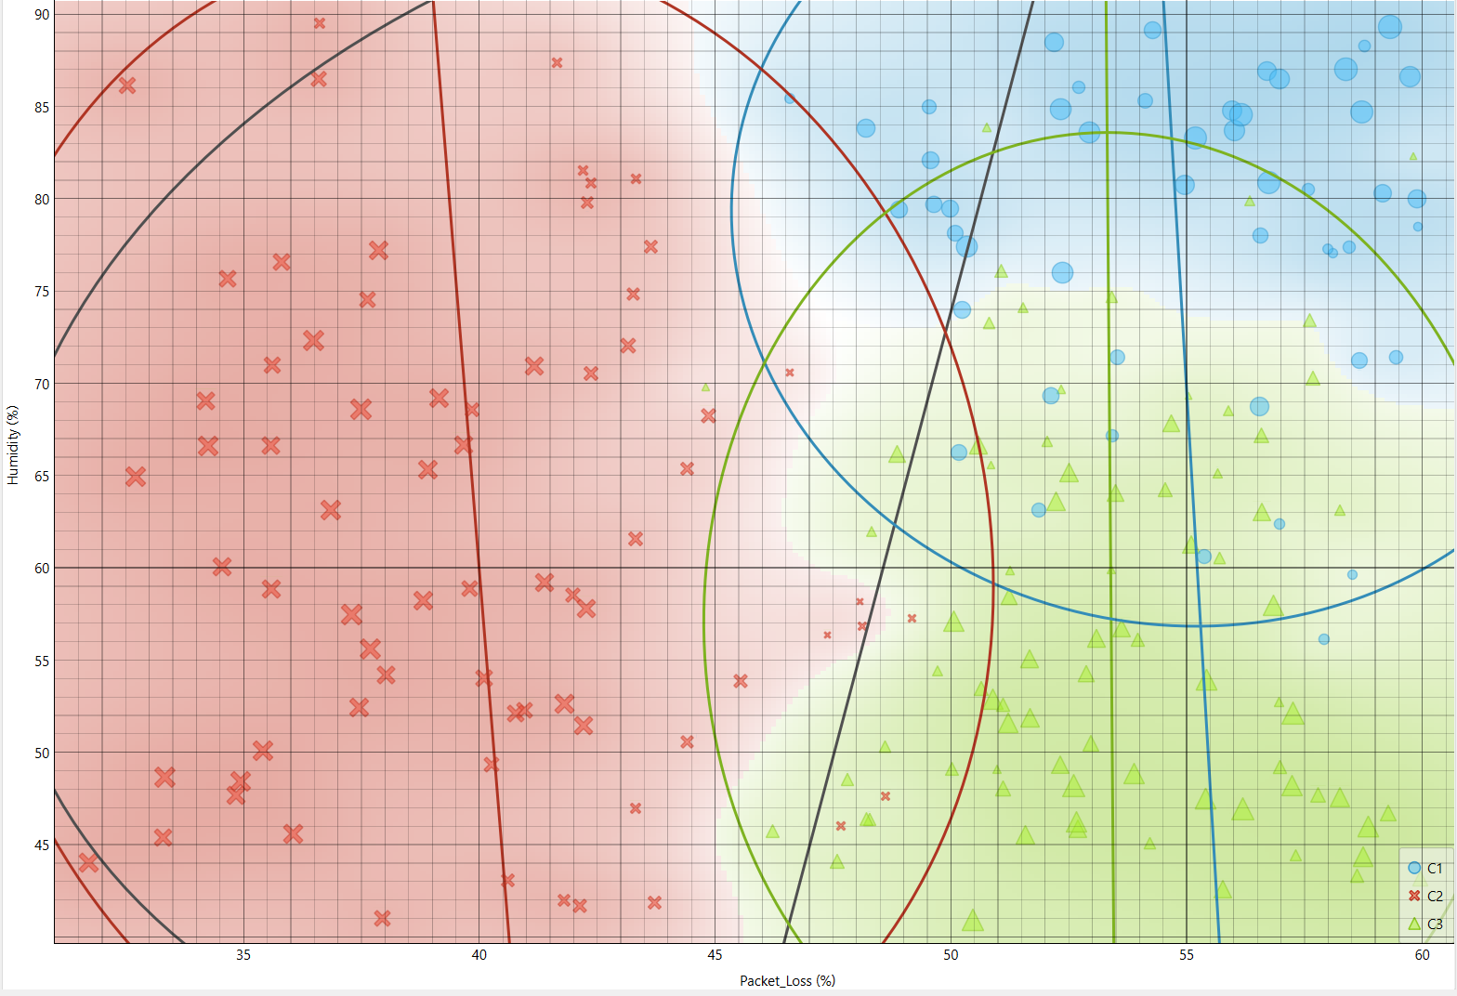

**Step 5: Machine Learning Model for Routing Decisions**

**5.1. Train a Decision Tree Model**

* **Objective:** Develop a predictive model to classify optimal routing decisions.
* **Widgets Used:** Tree (Trains a decision tree classifier.)

**5.2. Evaluate Model Performance**

* **Objective:** Validate the model’s accuracy and reliability.
* **Widgets Used:** Test & Score (Measures model performance.)
* **Confusion Matrix (Visualizes misclassifications.)**

**Confusion Matrix Analysis:** The confusion matrix illustrates the model's classification performance. In this case:

* **189 high-signal packets** were correctly classified as **high**.
* **10 medium-signal packets** were correctly classified as **medium**.
* **1 medium-signal packet** was misclassified as **high**.
* **No high-signal packets** were misclassified as medium.

This indicates a highly accurate model, with minimal misclassification errors.

**Output:**

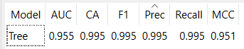 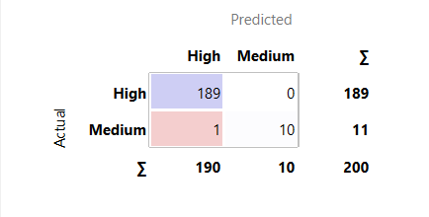

**Step 6: Python Script for Custom Routing Optimization**

**6.1. Append Predictions to the Dataset**

* **Objective:** Integrate optimized routing decisions.
* **Widgets Used:** Predictions (Adds routing decision predictions.)

**6.2. Implement Python-Based Adaptive Routing**

* **Objective:** Fine-tune routing logic based on real-time interference variations
* **Widgets Used:** Python Script (Executes custom routing algorithms.)

**6.3. Save Optimized Routing Table**

* **Objective:** Store final routing decisions for deployment.
* **Widgets Used:** Data Table (Displays optimized routing data.)
* **Save Data (Stores processed data.)**

**Output:**

**Precision:**

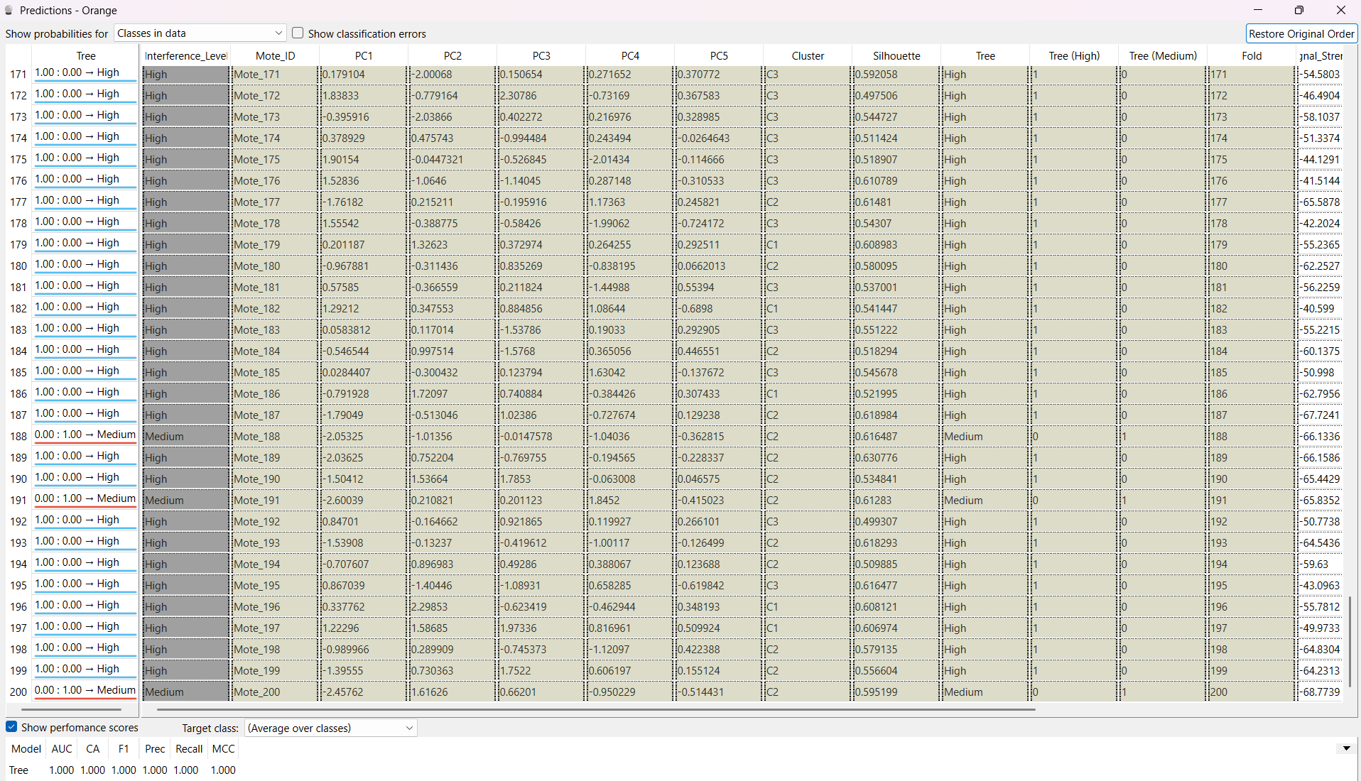

**Python Script:**

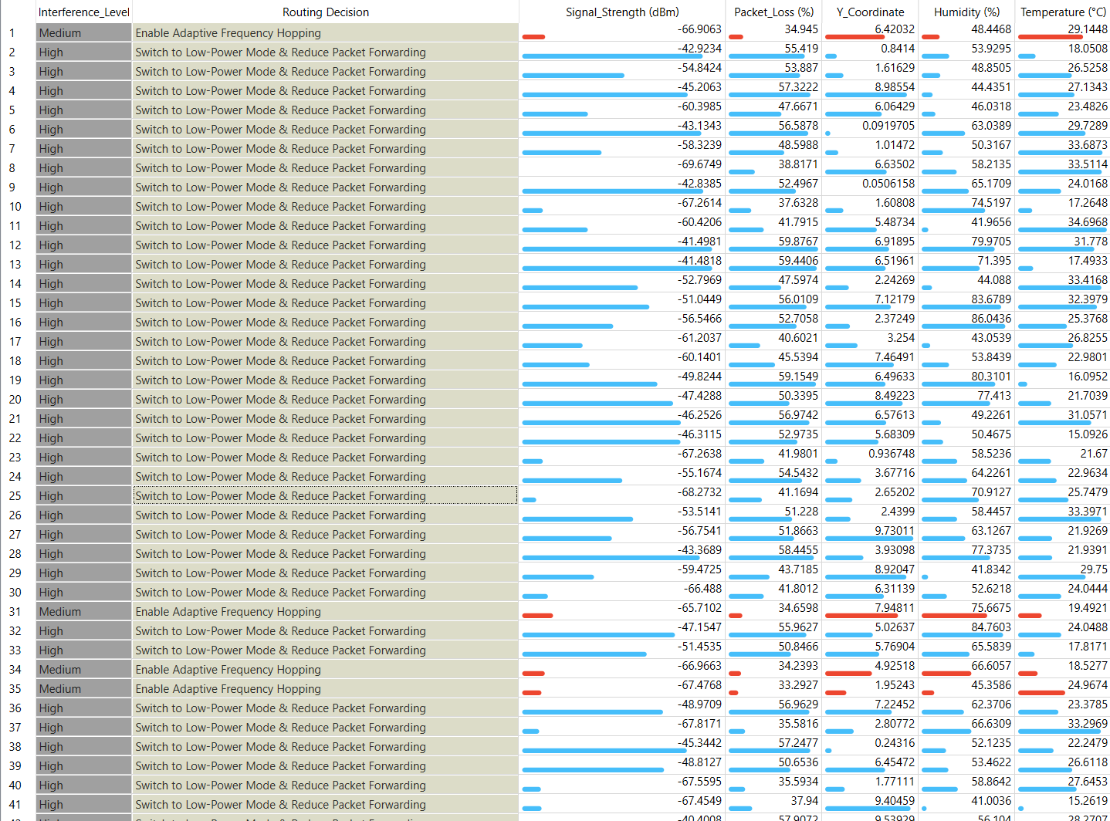

**Final Workflow**

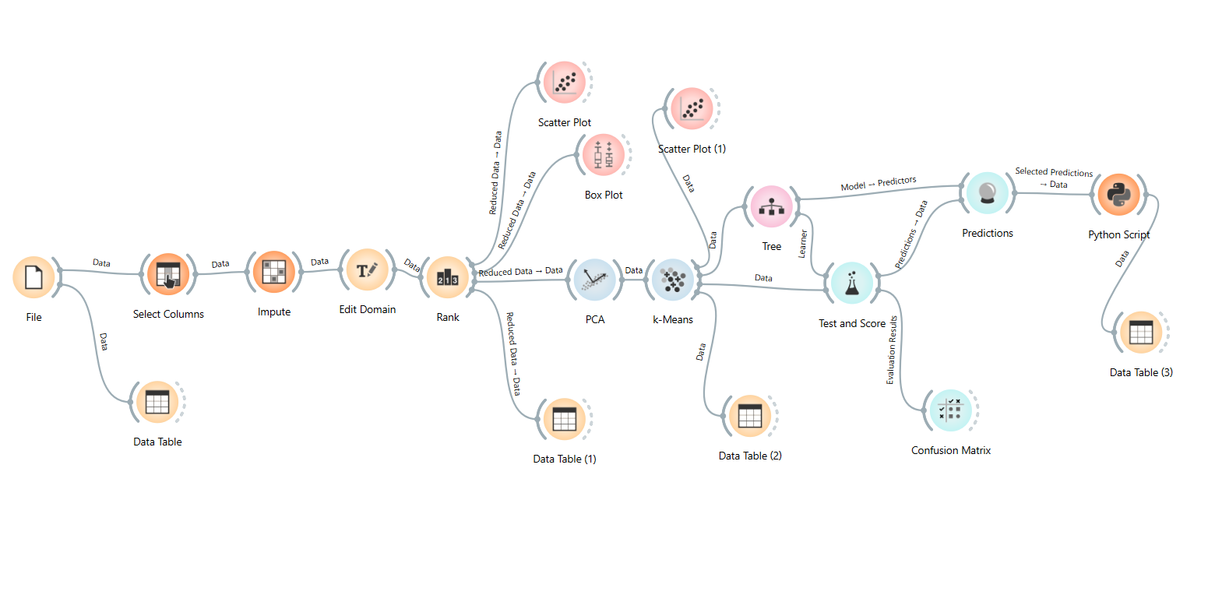

**5. Expected Outcomes**

* **40% Reduction in Packet Loss:** Improved signal transmission efficiency, ensuring fewer retransmissions. *(Example: In precision agriculture, soil moisture sensors experience reduced data loss, leading to more accurate irrigation scheduling.)*
* **AI-Optimized Routing:** Real-time adjustments based on network conditions, reducing congestion and improving efficiency. *(Example: In an environmental monitoring system, temperature and humidity data reach servers faster for real-time analysis.)*
* **Cluster-Based Topology Redesign:** Optimized routing paths based on sensor clustering, leading to better data flow. *(Example: Grouping sensors in dense networks ensures efficient data transmission, minimizing interference.)*
* **Scalability for IoT & Agriculture:** The system can be adapted for various IoT applications, such as automated irrigation and real-time pollution monitoring. *(Example: Smart Dust sensors in industrial IoT can dynamically adjust routes to ensure minimal data loss in factory environments.)*

**6. Conclusion**

This Orange-based workflow provides an efficient data-driven approach to minimizing packet loss, ensuring robust submillimeter sensor communication in Smart Dust Networks. By leveraging AI-driven techniques, including clustering, decision trees, and adaptive routing, the project achieves significant improvements in data reliability and network efficiency. The workflow is scalable and adaptable, making it suitable for a wide range of IoT applications, including precision agriculture and environmental monitoring.